

**Clenchwarton**

**Primary School**

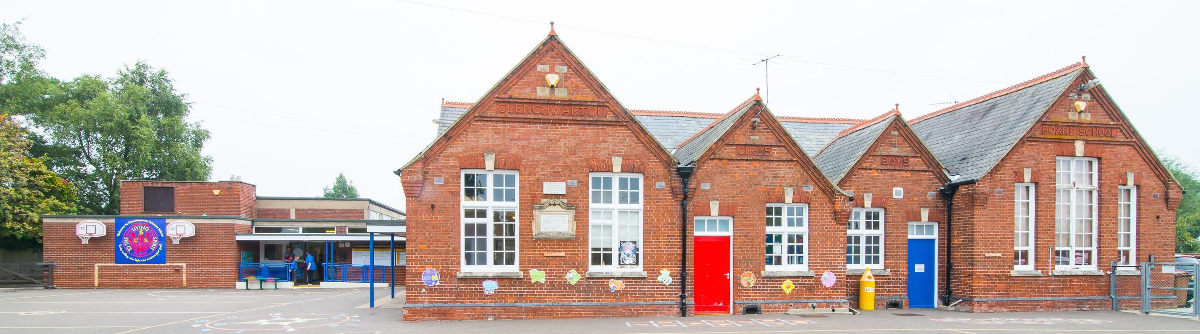



SCHOOL PROSPECTUS

2025 to 2026

Clenchwarton Primary School,

139 Main Road,

Clenchwarton,

KING’S LYNN,

Norfolk,

PE34 4DT

Telephone: 01553 775035

E-mail: [office@clenchwartonprimary.co.uk](mailto:office@clenchwartonprimary.co.uk)

Website: [www.clenchwartonprimary.co.uk](http://www.clenchwartonprimary.co.uk)

**Dear Parents and Carers,**

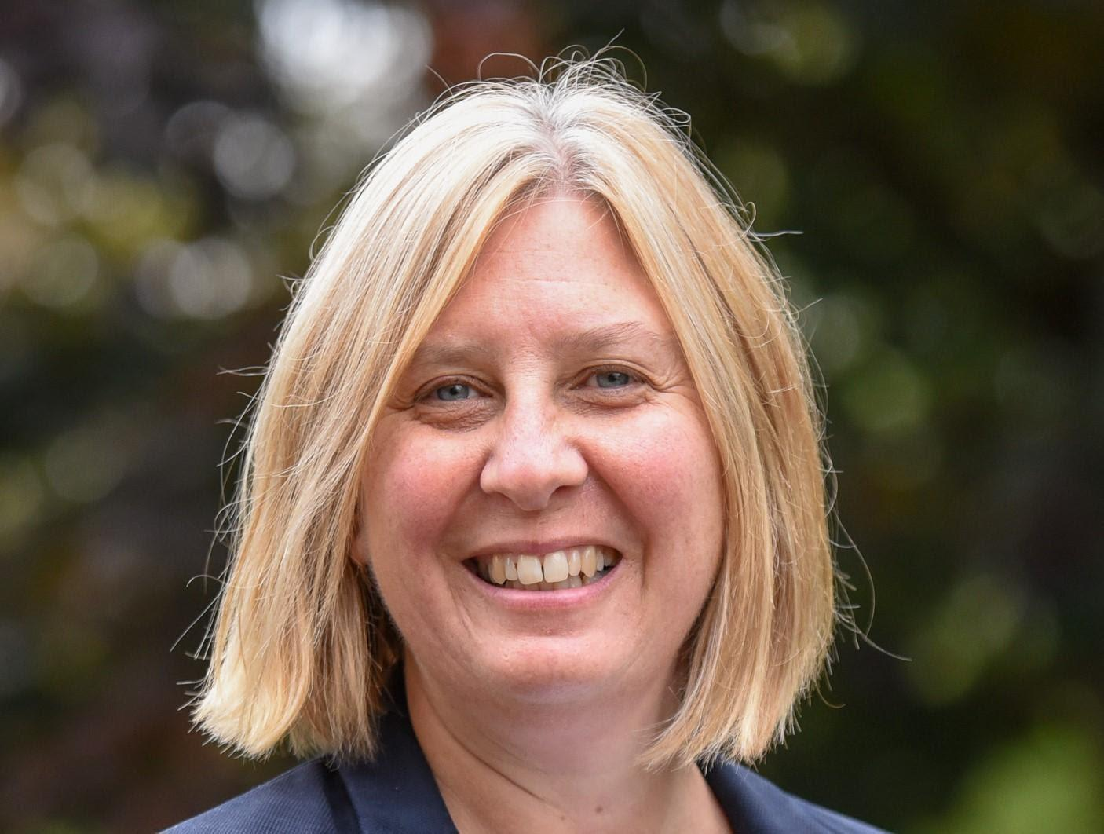

I would like to welcome you and your child to Clenchwarton Primary School.

I really hope that you will enjoy being part of our special school community and that your child will remember their days with us with pleasure and affection.

This prospectus is designed to give you an idea of the way the school is run and to give you information about the curriculum. I hope that you will find it useful, but it does not attempt to take the place of the vital personal contact between school and parents, which is essential for effective relationships to develop.

At Clenchwarton, staff and governors are committed to a partnership between home and school. We aim to create a stimulating and supportive environment, so that children are able to develop to the full extent of their ability. We all look forward to working with you.

Ms Joanne Borley

Executive Head Teacher





**Our Vision:**

Our vision is to create excellence in education, which values and promotes the pursuit of lifelong learning. Children will be inspired, challenged and encouraged, through a stimulating, supporting and caring environment where all achievement is celebrated.

**Our Values:**





**About Us**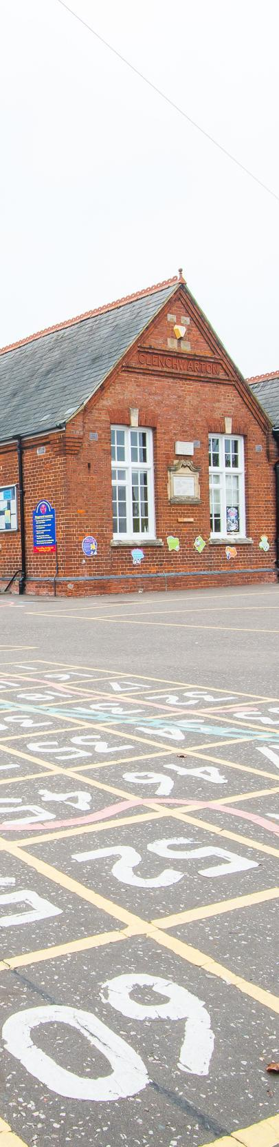

Our school has been on this site since 1895, but was originally housed in the village reading rooms until that date.

We are a single form school with seven classes. In addition to the main school buildings we have two mobiles which overlook the school playing field. Our school is well resourced for all curriculum areas, and the main school budget is supplemented with money raised by the PTA and our own School Council. We are part of the West Norfolk Academies Trust.

Various clubs are available after school, such as multi-sports, science, dodgeball, dance, cross-stitch, swimming, art, computer club and choir. These vary depending on the season.

We have a heated indoor swimming pool which is used during the summer term (April to July). All classes have a weekly swimming lesson taught by a member of our teaching staff who is trained to teach swimming and has passed the relevant life saving training. Our ICT Suite has 30 networked PC’s and we also have 16 ipads which can be used throughout the school. Each class has an interactive whiteboard.

Clenchwarton Primary School works within the West Norfolk Norfolk Academies Trust.  This means our students benefit from working in a close, mutually beneficial partnership with Gaywood Primary School, Snettisham Primary School, Heacham Infant School, Heacham Junior School, West Lynn Primary School and Walpole Cross Keys Primary School as well as Springwood, Marshland, and Smithdon High School's and our main feeder High School - St. Clements High School. The trust has a clear, strategic vision for the future, based on four key areas;

* World class standards of student achievement

* Strong community engagement

* Excellent standards of Teaching and Learning

* World Class resources for our school community.

**The School Day**

Children may arrive at school from 8.40 am (gates will be open from 8.35am), however teaching staff are not on the gate until 8.40 am. A member of staff is also on the gate at the end of the day.



**School begins: 8.45 am**

**Morning break: 10.30 am – 10.45 am**

**Lunch break: 12.00 pm – 12.50 pm**

**Afternoon break: 2.15 pm – 2.30 pm (KS1 and Reception only)**

**School ends: 3.15 pm**

**Admissions**

By law children must start statutory education full time at the beginning of the term following their fifth birthday. All children will be offered full-time positions in our Reception class. Should the parents not feel that their child is ready for full-time education at this time, they should contact the Head Teacher as soon as possible. The School’s admission limit in our Reception Class and Key Stage 1 is 30 and 30 in our Key Stage 2 classes.

Admissions to the school are handled by the Local Authority Admissions department.

In the event of over subscription the priority is:-

1. Children who are deemed as ‘looked after’ or have a statement of Special Educational Needs, which specifically identifies our school.
2. Children living in Clenchwarton.
3. Siblings of children already in the school.
4. Children from outside the village who have supported medical reasons for attending the school.
5. Children from outside the village based on geographical proximity to school.

Parents of children not offered a place at the school have the right of appeal to the Local Authority

**Attendance**

Registers are completed every day at 8.45am, any child arriving after this time will be marked as late. If your child arrives after 9:15am the mark will be noted as an unauthorised late arrival. This is also applicable if your child arrives back late after lunch.

If your child will be absent it is essential that you contact the school office by no later than 9.15am to inform us of the reason for the absence and every day of the absence. If we have not heard from you, we will either attempt to contact you by phone, text or email.

We have a responsibility to ensure that you and your children are safe, therefore if we cannot get a response from you by 1pm, we will arrange for two members of our staff to call around to your house. This is a safeguarding measure in line with our trust guidelines.

**The National Curriculum**

Curriculum requirements for all subjects are delivered through the new Primary National Curriculum (2014).

**Mathematics**

Maths is taught on a daily basis. We aim to ensure that all our pupils are confident with all aspects of maths. Significant importance is placed on developing the ability to use maths in everyday situations. Children are taught to use and apply mental and practical strategies to solve problems that they may face in day-to-day life. We aim to make maths as practical and fun as possible, using it in other areas of the curriculum as appropriate, especially in Information and Communication Technology (ICT).

**English**

In daily lessons, children are taught skills in reading and writing through a range of planned activities. Scaffolded activities support the less able and there are activities to extend the more able pupils. Skills and techniques are demonstrated and shared by the teacher through role modelling, shared class work, group and individual activities. Regular guided group work in reading and writing is led by the teacher or another adult in the classroom, including the use of the Read Write Inc programme in the Foundation Stage and Key Stage 1. Speaking and listening skills are taught through circle time activities and developed across the curriculum. The school teaches phonics through the RWI scheme and children take home a reading book based on their RWI or Accelerated Reader level.

**Science**

Essentially science is about exploring, investigating and discovering things to gain knowledge and understanding about the world we live in. We aim to provide children with the skills needed to investigate and explore ideas independently. As science is such a practical subject, it is taught using a hands-on approach wherever possible. Consequently, we have built up a full range of equipment and resources for children to use.

**Knowledge Based Curriculum**

Our School continues to use an established innovative curriculum based on the Core Knowledge sequence. The idea behind it is that all children should complete their primary education with a storehouse of general knowledge, along with self-confidence and skills to use it. The Core Knowledge Curriculum at our school prepares pupils for moving on to secondary schools and for leading their lives as citizens in modern Britain.

**Extra-Curricular Opportunities**

A variety of clubs are held each week to allow children to follow particular interests and develop skills, including Football, Book Club, Netball, ICT & Art.. A Cycling Proficiency Course is offered to children of 9 years and over. Voluntary activities are an important part of school life and encourage involvement and commitment on the part of children, staff and parents. Year 6 go on a school journey to Hilltop Outdoor Activity Centre near Sheringham each year and all classes take part in curriculum linked school trips and visits – and only take place when approved by the Head Teacher and the Local Authority. Trained first aiders are always in attendance on all school trips and visits.



**School Uniform**

School uniform is sold at Stratfords in King’s Lynn. [**Phone**](https://www.google.com/search?safe=strict&rlz=1C1CHBF_en-GBGB786GB786&q=stratfords+phone&ludocid=3923647740468747747&sa=X&ved=2ahUKEwitweX84PvoAhUbRBUIHdp2CqAQ6BMwFXoECBUQDg)**:**[01553 772043](https://www.google.com/search?q=stratfords+kings+lynn&rlz=1C1CHBF_en-GBGB786GB786&oq=stratfords+kings+lynn&aqs=chrome..69i57j0l7.7174j0j7&sourceid=chrome&ie=UTF-8).

The school uniform is compulsory and consists of the following items:

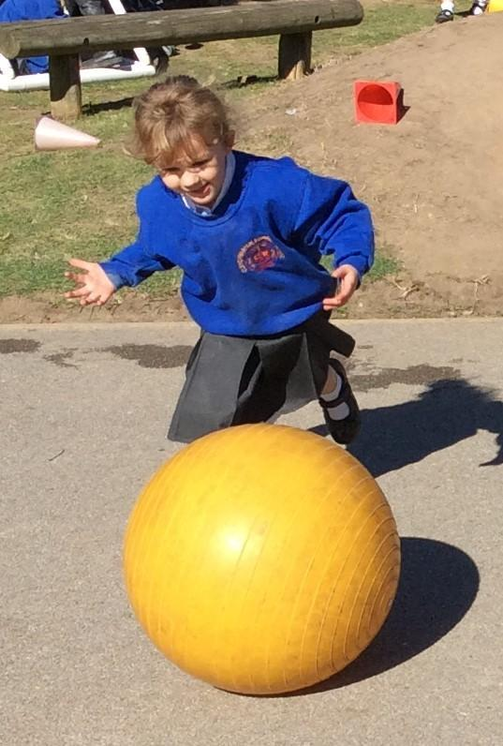





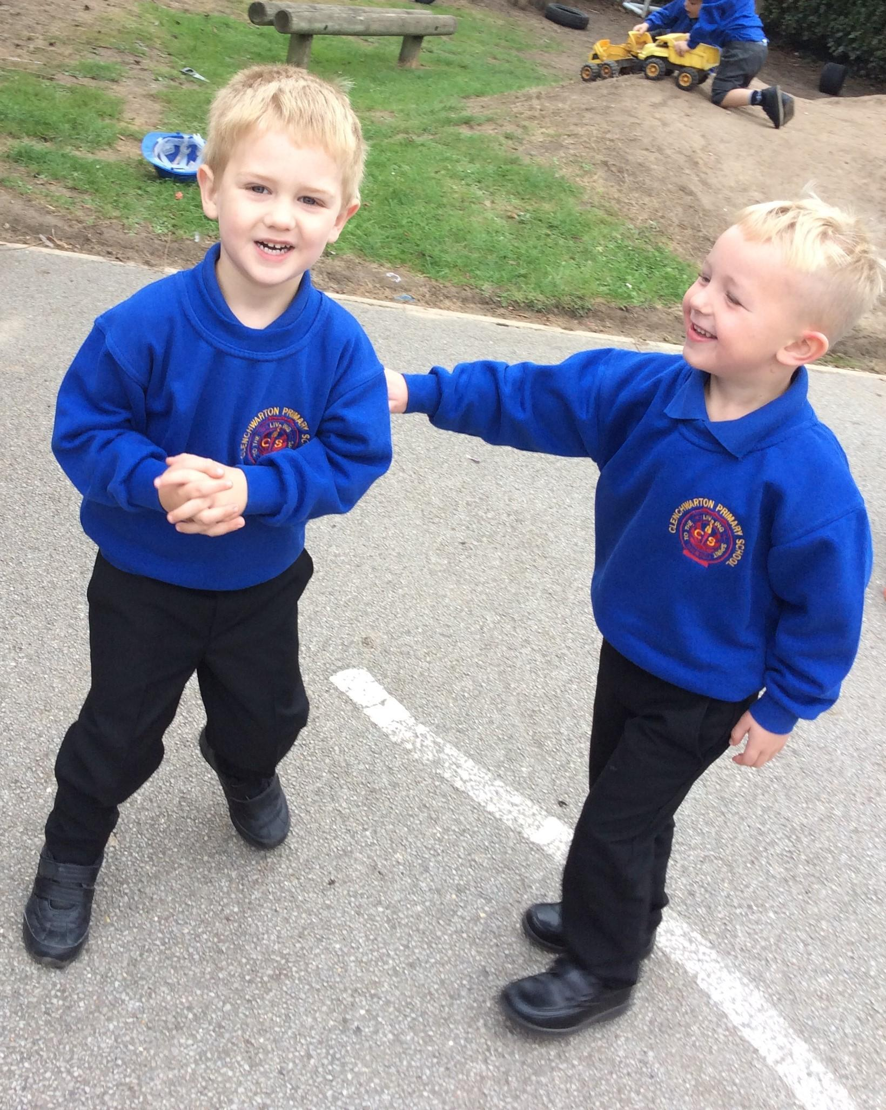

**School Meals**

Our excellent school kitchen provides freshly cooked healthy meals each day for children and staff. Children having school dinners pay the standard county charge each day for their meal with the exception of all children in Reception, Year 1 and Year 2 who are entitled to free school meals. All school meals should be ordered in advance via ‘My Child at School’ (MCAS app). Children may bring a packed lunch and should have their food in a named lunch box and a drink in a named and leak-proof container. Cans and glass bottles are not permitted. Children can bring their own healthy food for break time. We are a nut free school.

**Home-School Communication**

A school newsletter is produced and distributed via email to parents every week, which is also published on the website. Paper copies are available via the office. There are boards at the front of the school that are used for daily and weekly information and notices. Class curriculum presentations are given by all teachers in September and a letter is published in the spring and summer terms giving information about the term’s topic, homework and planned trips. We also use Class Dojo.

**Jewellery, Games and Toys**

Children are encouraged to dress appropriately for school and avoid extremes of fashion, especially footwear that can be dangerous and/or impractical at school! Stud earrings and watches are the only jewellery permitted. Any small toys or games that are brought into school are the responsibility of the owner and should be named. Older children who travel to and from school on their own are permitted to have mobile phones in school, but these should always be left in the main school office during the school day. All other children are not permitted to bring mobile phones to school. Children and parents can always use the school telephone system to leave essential messages.

**Special Educational Needs (SEN)**

Children are described as having Special Educational Needs when they have difficulties that affect their learning. SEN needs may range from relatively minor needs which may involve additional support from outside school to more serious concerns that may require an Educational Health Care Plan (ECHP). Regardless of the severity of the need, the children's progress is recorded and monitored throughout the school. At present many outside agencies visit the school e.g. Educational Psychologist and staff from the Learning Support Services. They may be called on to help children and give advice to staff. The school employs Teaching Assistants who work with SEN children and the child’s class teacher. The school has an SEN team to oversee the running of the school’s policy and ensure it is up to date and effective. We actively work towards an inclusive education for all our pupils.

**Assessment, Recording and Reporting**

Teachers regularly assess all children through daily live marking as this ensures that work appropriate to the child’s ability is planned. Children's progress is tracked throughout their school life. Formally, children will be assessed with National Baseline assessment in EYFS and then by using The EYFS Profile in Reception class. In Year 2 (7 years of age) they take the national Standard Assessment Tests (SAT’s) to aid teacher assessments, in Yr 4 the National Multiplication Test is delivered to assess time table knowledge and in Year 6 (11 years of age) pupils have statutory tests in reading, maths, grammar, spelling and punctuation. The results of SATs are published each year. Parents receive a written report on their child’s progress in February each year and a pupil attainment profile in July.  Parents are given the opportunity to meet teachers throughout the year to discuss their child’s progress.

**Medicines at School**

Our school policy allows staff to administer prescribed medication to children with written permission from parents/carers. Each class teacher has a file with copies of permission forms. Children who have inhalers should be able to administer their own medication, and inhalers may be kept in school in an agreed place, with the knowledge of the class teacher and Head Teacher. Parents may come into school to give medicine to their children, but parents must report to the School Office first. In the event of illness or accident, parents will be contacted and asked to collect their children from the School Office. It is therefore vital that we always have up to date contact details. An accident/incident report form is always completed after each accident/incident and a copy sent home listing full details of the accident/incident and the action taken. If a child bumps their head during the school day, a phone call to the parent/carer will be made.

**School Security**

All visitors to the school should report to the main office, sign in and wear a visitors badge whilst in school. Anyone collecting a child during the day for any reason should notify the office staff of their presence and intentions. All staff are alert to the need to report any person or occurrence, which may pose a danger to our children.

**Behaviour and Bullying**

Clenchwarton Primary School has embraced ’Restorative Practices’ when dealing with behaviour issues. We have done this as a means of empowering all members of our school community to be successful and become aspirational, motivated and responsible learners. Restorative Justice is about encouraging offenders to be accountable for actions and to take responsibility for repairing the harm caused. Restorative Practice is an ethos which must be fully embraced by children, staff and parents in order to work, however please be assured that serious incidents will of course be dealt with outside of this practice as necessary. Please see our Behaviour Policy on website for more details.

**Our School Rules:**



**Charging Policy**

Under the terms of the 1981, Education Act the school makes no charge towards educational activities, materials or transport (other than overnight accommodation). However, the school does not have sufficient funds to cover the cost of all trips, outings or school journey, and therefore must ask for voluntary contributions in order for these activities to take place. Parents may be asked to pay for materials used in cooking and certain crafts, if they agree in advance that they wish to own the finished product.

**Complaints**

Any concerns or worries about the curriculum, children in the school or the workings of the school or staff should, in the first instance, be taken to the class teacher. Many of our school policies are available online through our school website; however, you are welcome to request to see policies by appointment. If you feel your concerns have not been addressed or you have a complaint about the Head Teacher or an individual Governor, this should be referred to the West Norfolk Academy Trust.

**Our PTA (Parent Teacher Association)**

All parents and carers of pupils at the school, all members of staff and the Head Teacher are automatically members of the Clenchwarton Primary School Parent Teacher Association. This is an active group of fundraisers made up of parents and staff who are appointed annually at the Annual General Meeting, held in the autumn term each year. The aim of the PTA is to encourage good relations between staff, parents and others associated with the school and to raise funds that enable the children to have more than school finances allow. Funds are raised by arranging social functions. Over the last few years, the PTA has provided many extras for the children, including subsidising trips, a trim trail and leavers hoodies. They are currently raising funds to replace the school sound system.



**Clenchwarton Primary School - Basic Information**

Name of school: **Clenchwarton Primary School**

Type of school: **Primary**

Status: **Academy**

Age range of pupils: **5 to 11 years**

Head Teacher: **Ms J. Borley**

Address of school: **Main Road, Clenchwarton, King’s Lynn,**

**Norfolk, PE34 4DT**

Telephone: **01553 775035**

Fax: **01553 773186**

Website address: **www.clenchwartonprimary.co.uk**

Chair of Governors: **Mr R. Wenn**

Local Authority: **Norfolk**

Number on roll: **207 (May 2025)**

Cost of school lunch: **£2.60 (Free for children of YR, 1 and 2)**

School Day Begins: **8.45 am**

School Day Ends: **3.15 pm**

We run ‘My Child At School’ (MCAS) - a service where parents can order and pay for their children’s school meals from home. For additional information about this service, please see the school receptionist.

**School Term Dates 2025 to 2026** Please see the sheet below for school term dates. 1st/2nd September 2025, 5th January 2026 and 13th April 2026 (children do not attend on these days). Additional dates information regarding school INSET Days and additional school holiday days are given in our weekly newsletter.

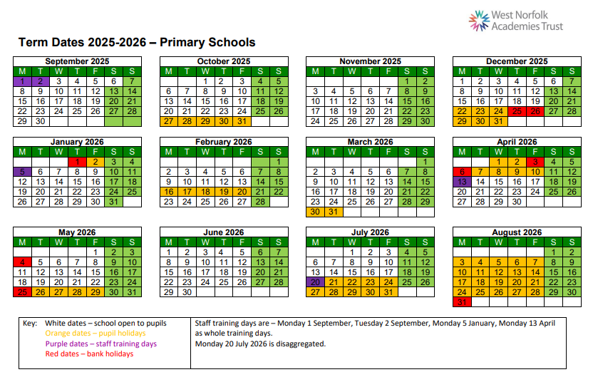

**Safeguarding and Child Protection**

At our school, the health, safety and well-being of every child are our paramount concern. We listen to our pupils and take seriously, what they tell us. We are committed to safeguarding and promoting the welfare of children and young people and all staff, volunteers, visitors and outside agencies are expected to share this commitment and report any concerns to one of our Designated Safeguarding Leads. If we have any concerns about a child, we will (in most cases) talk to parents/carers in the first place. If we feel we need to seek further professional advice, we will explain that we would like to make a referral to the Children’s Advice and Duty Service (CADS). This service is manned by a multi-agency team and will help the school get the right advice and support in regards to any next steps. We will always work closely with parents/carers to ensure that the children are getting the most appropriate support and help. Parents may seek advice and guidance from the Designated Safeguarding Lead or CADS directly. Our Safeguarding Policy is available on our website or from the office on request.

Our school is also part of Operation Encompass. Operation Encompass is a national scheme that operates jointly between schools and the police force when a child or young person has been involved or exposed to a domestic abuse incident. Operation Encompass will ensure that a Designated Safeguarding Lead is given information, in confidence, to be able to make provision for possible difficulties experienced by the children, or their families, who have been involved in, or exposed to, a domestic abuse incident. Any information shared as part of this scheme is kept confidentially by the school.

**School Staff** 

**Leadership Team**

Ms J. Borley – Executive Head Teacher

Mrs N. Maddison - Executive Deputy Head Teacher

Mrs C. Howells – Assistant Head Teacher

Mrs M. Ryan – Senior Leader

**Pastoral & Attendance Officer**

Mrs G. Scott

**Teaching Staff**

Miss A. Webb - Year 6

Mrs C. Howells – Year 5

Mrs M. Ryan – Year 4

Miss S. Tarsey – Year 3

Miss C. Golding/Mrs A. High – Year 2

Miss K. Welch – Year 1

Mrs J. Williams – Reception

**Higher Level Teaching Assistant**

Miss R. Burgess

Mrs P. Wiles

**Cover Supervisor**

Mrs R. Hurn

**Teaching Assistants**

Mrs R. Adair

Mrs P. Bland

Mrs S. Bolderstone

Miss E.Smart

Mrs J. Calaby

Mrs M. Greehy

Mrs S. Harpley

Miss A. Lightfoot

Mrs E. McHale

Ms L. Rascher

Mrs A. Real

Miss H.Tordoff

Mrs N. Upton

Mr R. Robinson

Miss S.Smalley

Miss L. Morell-Bowley

**SEN Teaching Assistants**

Mrs C. Nicholls & Mrs S. Pepper

**SEN Team**

Ms Rachel Bazeley-Smith – Trust SENCO & Mr D. Furzey – Trust Assistant SENCO

Mrs G Harris - SEN Administrator

**Administration**

Mrs H. Mann *(PA to the Head Teacher)*

School Receptionist - Mrs K. Rhodes

**Site Management -** Mr R. Hayes

**Mealtime Supervisors**

Mrs R. Adair, Mrs E. Brandon, Mrs G. Franklin, Mrs T. Gotsell, Mrs S. Harpley, Mrs H Kerns, Mrs C. Nicholls, Mrs S. Pepper, Mrs N. Upton, Miss S Smalley and Miss H Tordoff